**Experiment 4**

Docker Build and Push using GitHub Actions

**Objective: Set up a GitHub Actions workflow to automatically build a Docker image from a Dockerfile in your GitHub repository and push it to a container registry (e.g., Docker Hub).**

**Prerequisites:**

**GitHub account**

* Docker installed on your local machine
* A Dockerfile in your GitHub repository
* A Docker Hub account (or any other container registry)

**Exercise Steps:**

**Step 1: Fork and Clone the Repository**

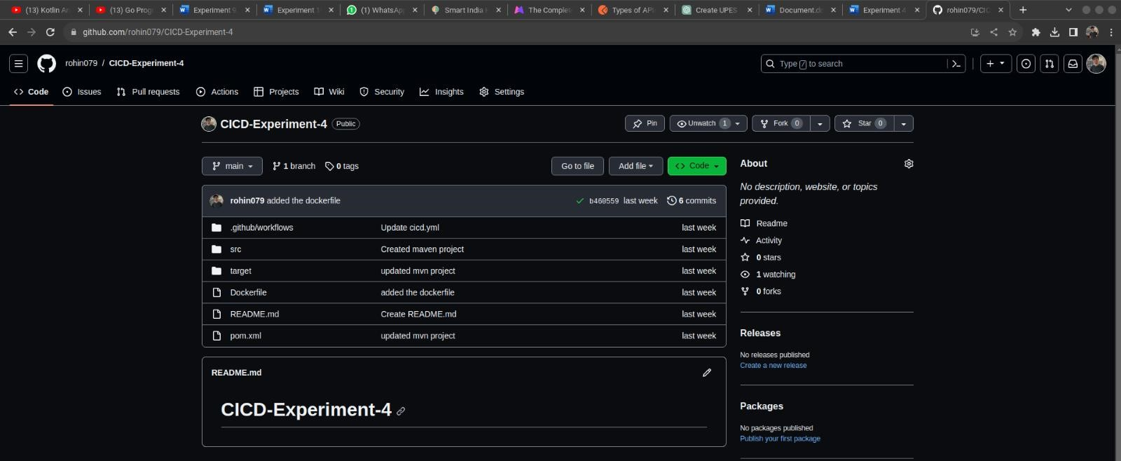

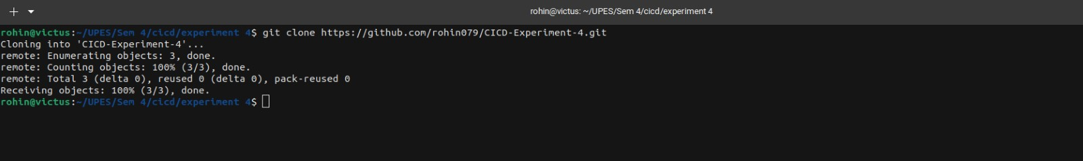

* Fork a sample GitHub repository containing a Dockerfile or create a new repository and add a Dockerfile to it.
* Clone the forked repository to your local machine.

**Step 2: Create Docker Hub Access Token:**

* Log in to your Docker Hub account
* Go to your account settings and click on the "Security" tab.
* Under "Access Tokens," click "New Access Token." Give it a name, select the required permissions (e.g., "Write" for pushing Docker images), and click "Create."
* Copy the generated access token. You will need it to authenticate with Docker Hub in your GitHub Actions workflow.

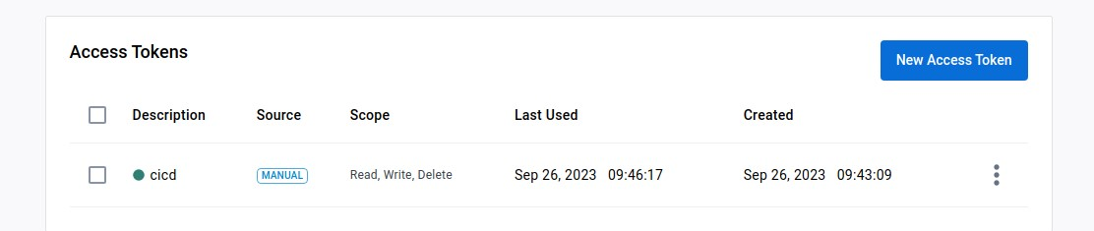

# Step 3: Create a GitHub Actions Workflow

* In your cloned repository, create a directory named .github/workflows if it doesn't exist.
* Inside the .github/workflows directory, create a YAML file (e.g., docker-build-and-push.yml) to define your GitHub Actions workflow. You can use any text editor to create the file. • Edit cicd.yml

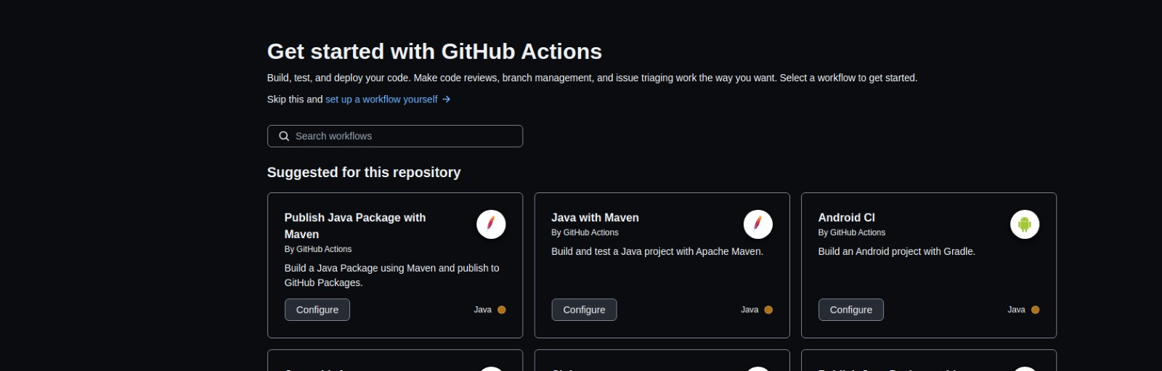

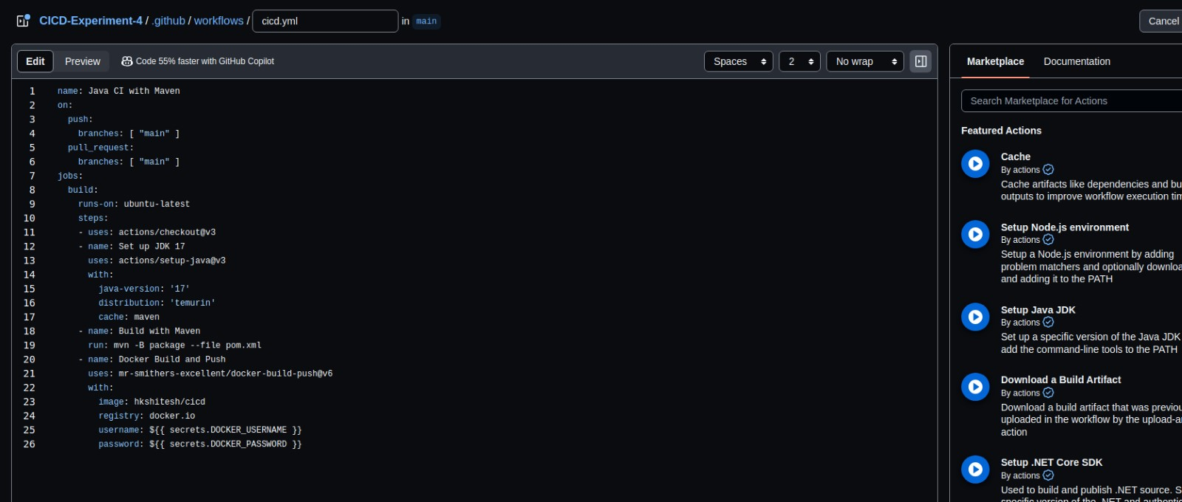

**Step 4: Add Docker Hub Credentials to GitHub Secrets**

* Go to your GitHub repository on the GitHub website.
* Click on "Settings" and then "Secrets" in the left sidebar.
* Click on "New repository secret" and add two secrets:
* DOCKER_USERNAME: Set this to your Docker Hub username.
* DOCKER_PASSWORD: Set this to the Docker Hub access token you generated earlier.

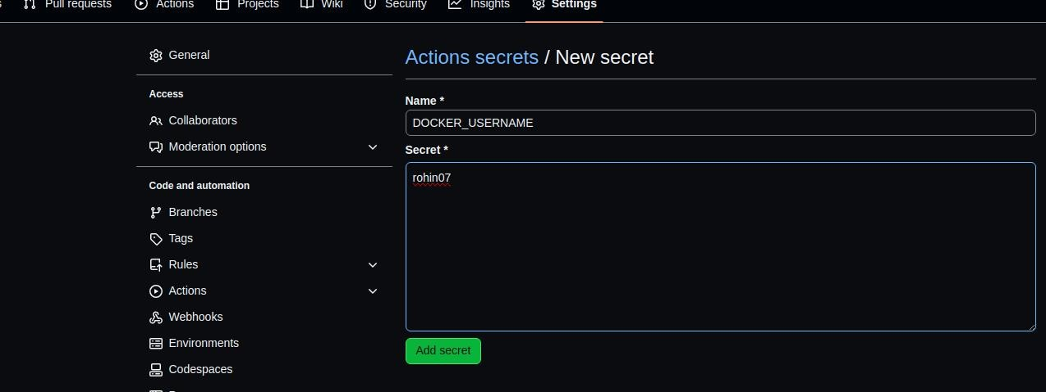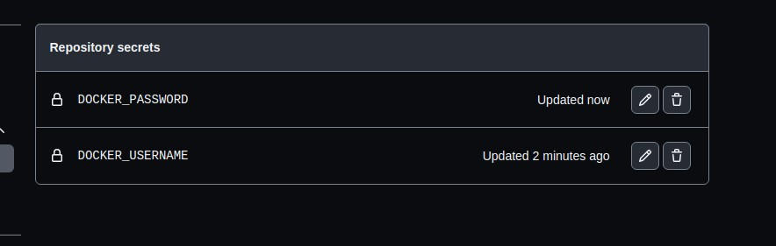

**Step 5: Commit and Push Changes** Save the docker-build-and-push.yml file.

Commit the changes to your local repository:

# Step 6: Check the Workflow Status

* Go to your GitHub repository on the GitHub website.
* Click on the "Actions" tab to see the workflow running. You should see a workflow named "Docker Build and Push" or the name you specified in the YAML file.
* Monitor the workflow's progress, and once it is completed successfully, you should see a green checkmark indicating a successful build and push of the Docker image to Docker Hub.

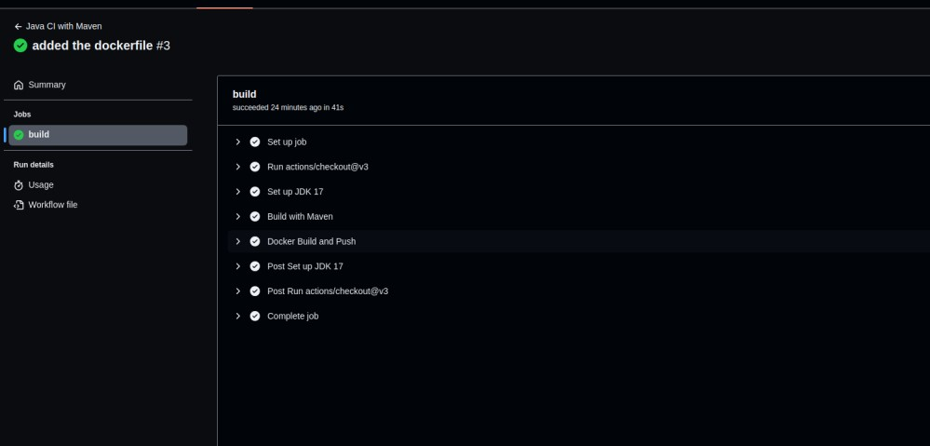

# Step 7: Verify the Docker Image on Docker Hub

* Log in to your Docker Hub account.
* Navigate to your Docker Hub repository, and you should see the Docker image you pushed from the GitHub Actions workflow.

